Achain 2.0 Mainnet Latest Development:
Test web browser officially launched

Following the launch of the Achain 2.0 mainnet [test network] on July 31, Achain today officially launched the Achain 2.0 test browser. Click: https://explorer.achain.com/#/
or click on “Browser” on the menu bar of the Achain website to access transactions in real-time on the 2.0 network.

Achain 2.0 test web browser view：
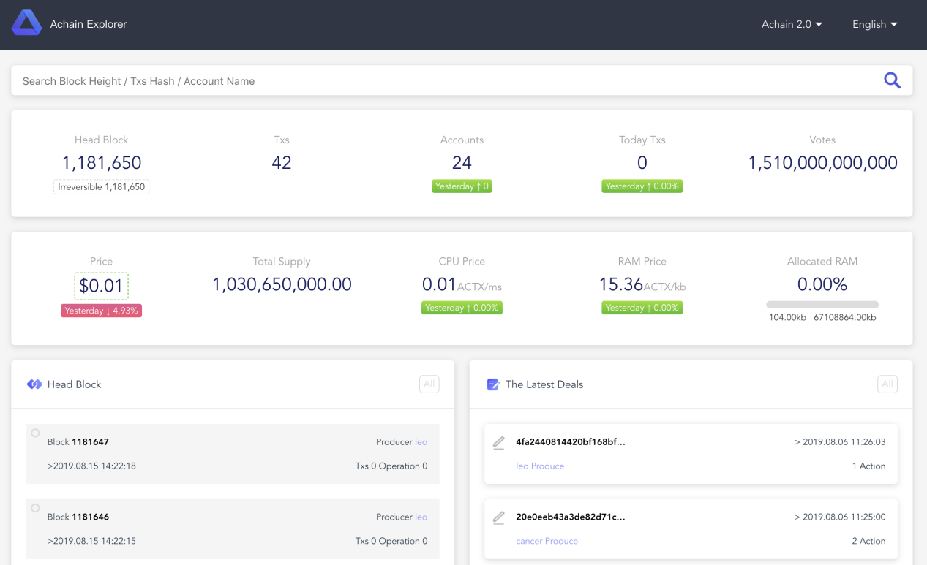
“Trustless” is a core blockchain attribute defining how transactions are verified without the intervention of third-party middlemen. Blockchain networks are built on transparent, distributed ledgers and the immutability of on-chain data. Browsers play a critical role in allowing users to query the contents of each block, and to access data on the ledger. Where an ordinary user might simply trace a personal transaction to verify completion, miners, analysts, investors, security teams, and other power users rely on the essential data in blocks to trace transactions and frequently, to maintain the blockchain itself.

The Achain 2.0 test network blockchain browser aims to provide users with different block-related queries such as transaction information, block information, and account information. The Achain browser is particularly developer-friendly. Its intuitive interface and testing tools enable developers to quickly access the required information.

The Achain Test Network 2.0 blockchain browser main interface is simple and elegant. Using the search bar, one can easily access information such as block height, transaction ID, account name, etc. The main interface displays important details such as head block,txs, accounts, today txs, votes, price, total supply, CPU price, RAM price and allocated memory. The browser additionally compares the change in value (rise and fall) of the coin with the previous day, providing convenient price information for investors concerned about trading.

The browser homepage displays the latest block details such as data of generator, generation time, and block node in real-time. Click to enter detailed information such as block hash, operand, publisher, etc. The browser can also leverage the transparency of our network by displaying the raw data of the block.

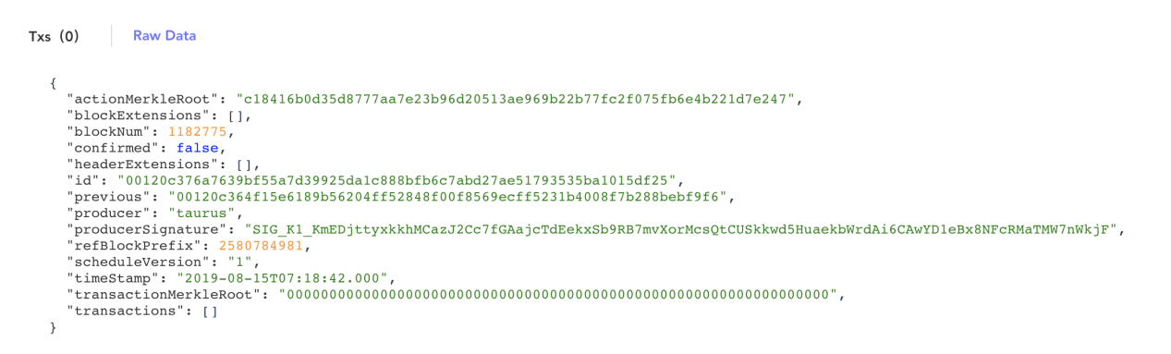
For each detailed transaction hash, users can also view a series of data such as status, block time, expiration time, block contract, type, etc.

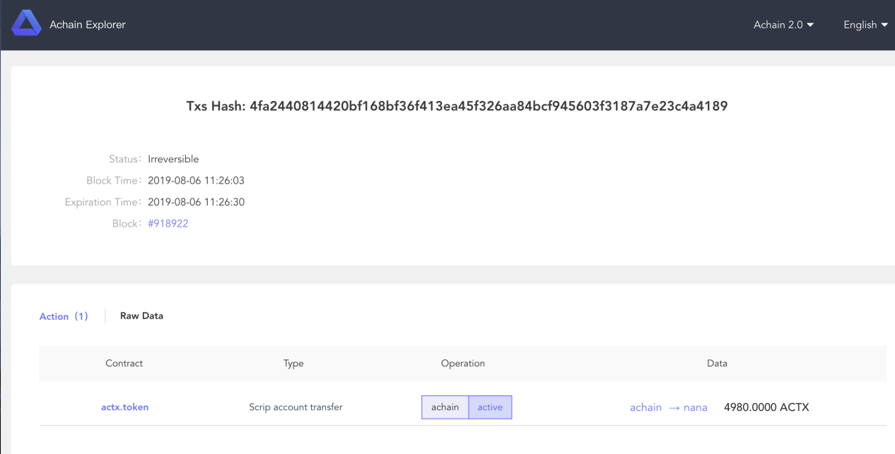

The new browser also provides information such as the ACTX (the Achain 2.0 mainnet [test network] token) Top Holders, RAM Top Holders, and showing the total assets (ACTX) / holdings (kb), occupancy, etc. Users can click on a single list node to view its detailed data, including the ACTX total balance, RAM/CPU/NET, the CPU/Net that is being mortgaged and mortgaged by others and the ACTX being redeemed is for the user to refer to the trusted node for the mortgage.
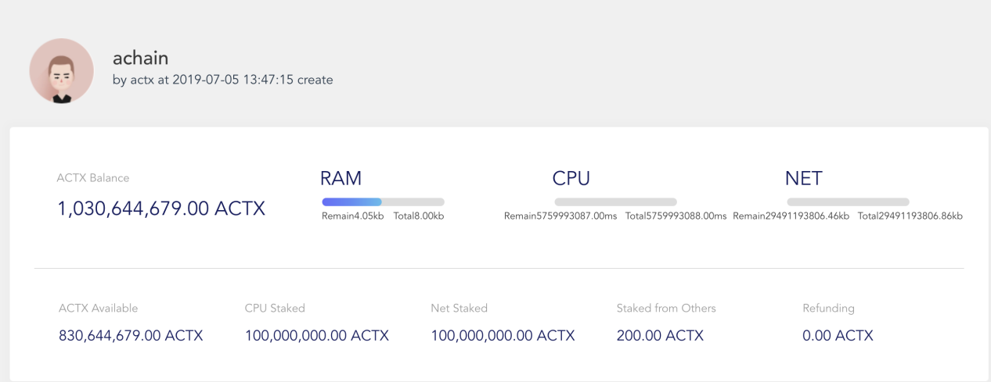
Users who prefer to use the 1.0 browser can also switch via the drop-down menu at the top right corner of the homepage.
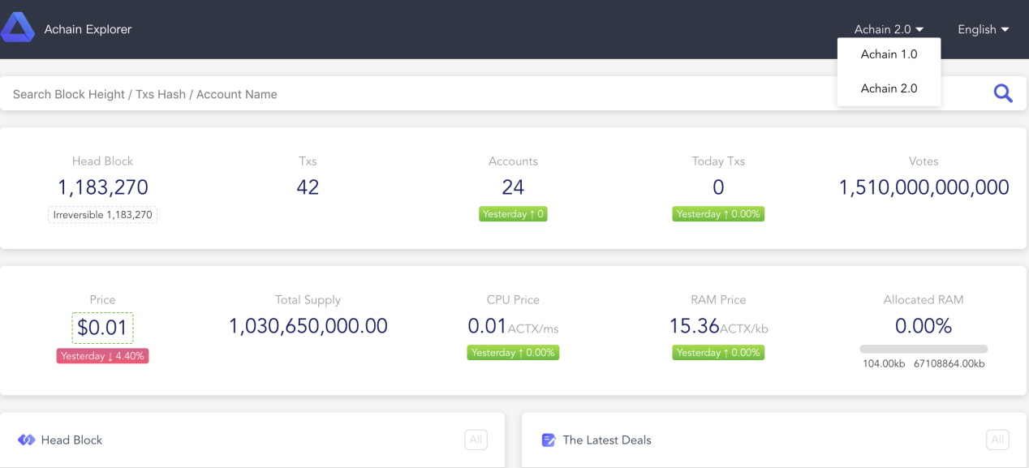
Achain 2.0 focuses on the construction of multi-chain galaxies with strong contract performance, short data synchronization processing time, and support for multi-language programming. The Achain 2.0 official test web browser provides detailed data on the chain further reducing the threshold for developers. Achain founder Cui Meng said: "We welcome developer communities to the Achain Galaxy to experience the Achain 2.0 test network and blockchain browser. We welcome any feedback and suggestions to support developers. We will listen to the community voice and constantly optimize our products and technologies in preparation for the official production release of the Achain 2.0 mainnet. Soon the Achain 2.0 wallet will be launched along with a series of matching tools to support developer innovation. With the frequency of contract calls and transactions increased in the future, users can observe the full picture of the Achain Galaxy ecology through the blockchain browser.

