“CRYPTOS ARE THE FUTURE OF FINTECH - COINDCX AT TECHSPARKS”

CoinDCX was present in India’s Largest Startup Conference - Techsparks to represent the entire cryptocurrency community. We took the responsibility of spreading the right knowledge of blockchain and cryptocurrencies in this event which was attended by globally recognized personalities like S Iswaran (Minister for Communications and Information, Minister-in-charge of Trade Relations Republic of Singapore), Vijay Shankar Sharma (CEO, PayTm), Bhavish Kumar (CEO, Ola), Dr. Ashwathnarayan C. N. (Deputy Chief Minister of Karnataka), Munish Varma (Managing Partner, SoftBank Investment Advisers), Manu Jain (VP & MD, Xiaomi India), and Kalyan Krishnamurthy (CEO, Flipkart).
Techsparks was scintillating having thousands of growing companies working towards the common goal of growing India’s entrepreneurial setup to match it with the global momentum. CoinDCX established the importance of crypto-based services in this event and how these services can play a crucial role in financial inclusion of billions of people globally.

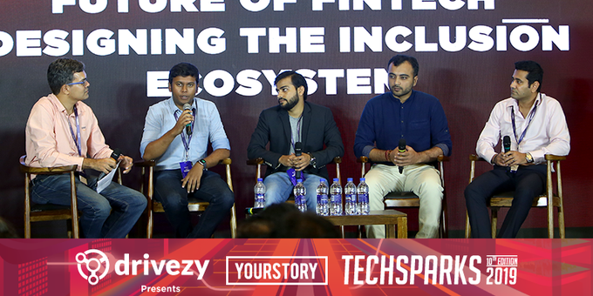Left to Right -

Sumit Gupta, Co-founder and CEO CoinDCX, shared the stage with the founders from eminent FinTech companies such as RazorPay, OKCredit, IndiaLends and Amazon Payment services. After a short introduction by Techsparks, we dived straight into the future Fintech holds to make financial services accessible to everyone in India. The 45-minute discussion delved into different services like digital finance, crowd-lending services, mobile payments, decentralized finance, and crypto-based products. During the discussion, Sumit said, “Right now people want instant gratification. Like UPI made instant payments possible within India, cryptos can help you make instant transactions worldwide.”
Sumit, who has been a persistent evangelist of decentralized finance (DeFi) added, “Personally, I am a big believer in blockchain. Let’s take one example. When the Internet first came into existence, it was the transfer of information in a distributed manner. The same principle applies to blockchain. The technology is still in its nascent stages and the regulatory confusions surrounding them have caused a minor slowdown in the economy. Once there is more clarity in the regulations, cryptocurrency companies can take the mandatory steps together to make India one of the most Fintech and crypto-friendly nation in the world.”
Shashank Kumar, founder of RazorPay, expresses his concerns on how the transaction volumes on his platform were severely affected after the RBI ban. He added, “We saw a major boost in volume when the cryptocurrency boom happened. It was the largest form of money movement at the time. After the ban was imposed, there was a sudden drop in the volume of active users and transactions.” The discussion went further on the market drivers which supports the adoption of crypto-based instruments. Sumit also answered the questions from the audiences in which he clearly explained the dynamics of blockchain, network effect, and the repairs decentralized financial services can do in the currently ruptured financial system.

CoinDCX’s team met people from different industrial sectors which include government officials, company executives, board members, entrepreneurs, and journalists in the span of these two days. Numerous discussions on crypto-related topics like their security, trading platforms, payment and lending services, technical infrastructures, business logics, benefits to the unbanked population, financial inclusion etc. were discussed with these renowned participants. For us, the success of this event can be measured based on the interest the participants showed towards cryptos as our solid purpose of promoting this industry on behalf of the entire community was fulfilled after having these discussions.

