Plethori: The World’s First Crypto ETF Creation

and Trading Platform — Powered by Polkadot
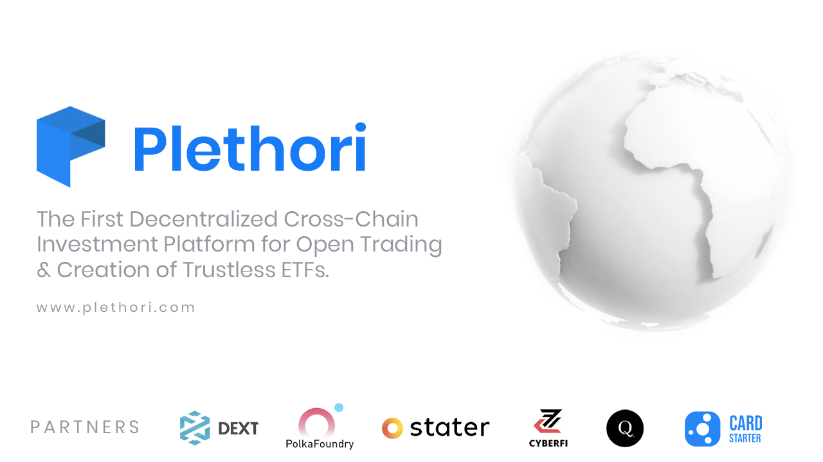
It is Q2 2021, and the true era of decentralized finance has now begun. It is safe to say that the rough terrain has been chartered and that DeFi is here to stay.
With a solid foundation formed, the time has come for serious investors to enter the realm of decentralized finance. And with them comes the increase in demand for bona fide financial products and services.
Complex traditional investment structures will soon begin to enter the crypto space. With incredible foresight, PLETHORI has risen to meet these demands, and will soon be launching cryptocurrency’s premier ETF Creation and Trading Platform.

ETFs
Exchange-traded funds (ETFs) are investment funds made up of multiple assets within a particular industry. Their value is derived from the index value of the group of assets contained within it. Advantages include lower fees, diversification of one’s portfolio, and the ability to invest in the strength of a sector, rather than relying on the success of individual projects.
The current value of all ETFs worldwide is over $7.7 trillion, and as traditional financial markets begin to feel the pressure of a declining global economy, investors all over the world are turning their attention to the rapidly expanding decentralized alternative. This increase in demand has opened the market to the idea of accommodating some of the more complex instruments that have previously only existed within the traditional financial industry.

Plethori’s Platforms
V1 Platform
Plethori’s debut product, the V1 Platform, will offer investors the opportunity to buy and sell a wide range of crypto-based exchange-traded funds (ETFs).
How will it work?
The V1 Platform will provide a variety of ETFs, each made up of a select portfolio of tokens from different cryptocurrency sectors, for example — NFTs, Polkadot projects, Layer 2s, Insurance projects, Oracles, high market caps, low market caps, etc. Full details on each available ETF will be provided before the platform’s launch.
Users will be able to buy and sell Plethori’s ETFs on the exchange platform. The sole market will be ETH initially and a DOT market will be integrated later in 2021. Holding the PLE token will be the only pre-requisite to gaining access to the platform.
No user account is necessary. Simply connect your wallet containing PLE and you will gain full access to all of the platform’s features.
Platform Features
- The Exchange : The V1 Platform is essentially a decentralized exchange where users will be able to buy and sell the wide range of ETFs available.
After connecting one’s wallet, users will be able to: place market orders; place limit orders; view their portfolio; check out their P&L and trade history; and follow all of their favourite ETFs closely, enjoying the full range of available statistical data for each.
Users will also be able to chart all listed pairs on the 1m, 5m, 15m, 30m, 1hr, 4hr, 12hr and 24hr time frames. The platform, available in both Day and Night modes, will have a range of charting tools and indicators and users will be able to select either bars, lines or candlesticks to suit their preference.
- Low Fees : Rather than paying 10 transaction fees (for example) to purchase 10 different tokens, ETFs allow investors to purchase all 10 different tokens for just 1 transaction fee. With the increasingly high fees on various networks (not mentioning any names!), traders often have to allocate inordinate quantities of their available capital toward fees. Plethori’s ETF structure means that more of your money will be actively invested, rather than disappearing into network miners’ wallets.
- Diversification : ETFs facilitate portfolio diversification with a single purchase. Rather than relying on the success of an individual project, ETFs spread the risk by indexing the value of multiple tokens across a sector or industry.
ETFs are an essential component of any strong investment portfolio. Their ability to provide instant diversification with minimal exposure to trading fees is a great way of hedging risk whilst simultaneously freeing up capital.
Bringing ETFs to crypto like never before, Plethori’s V1 Platform delivers a unique product to a market hungry for such innovation. And with its very well thought out UI and clean and professional design, investing has never been easier on the eye than it is with Plethori.
V2 Platform
Plethori’s V2 Private Funds Platform is set for launch later in Q2 2021. For the first time, investors will be able to create and manage their own decentralized exchange traded funds. Tradeable on the V2 exchange, these unique ETFs will not only provide creators with a passive income, but introduce gamification through leadership boards and rewards, with NFTs playing a key role.
How will it work?
The V2 Platform will allow users to stake collateral in exchange for the ability to create personalized ETFs with their own unique portfolio of tokens. Once created, these unique ETFs can be published and made available for purchase by other potential investors. Fund creators will earn a percentage of all transaction fees associated with the purchase and sale of their unique ETFs. The better the performance of the ETF, the higher up the leader board the fund manager ranks and the more likely other users are to purchase their ETFs.
“Gosh, I wish I did. If I had a tenth of a basis point of the ETF business, believe me I’d be out there sailing a yacht.” — Nathan Most, commenting on the fact that he never received a dime in royalties for creating ETFs.
Platform Features
The V2 Platform boasts all of the same elegant features as the V1 platform, with the addition of the ability to create and trade custom-made ETFs.
- The Exchange : As with Plethori’s V1 Platform, the V2 will also act as a decentralized exchange. Once users connect their wallets via the Web3 app they will be able to place market orders, limit orders and set stop losses, engage in margin trading and leverage trading, view their portfolio and check their trade history.
- ETF Creation : All platform users will have the ability to create their very own customized ETFs and release them onto the exchange. All projects that are built on Ethereum or Polkadot will be offered for inclusion in the ETFs, with Cardano and Bitcoin in the pipeline.
- Passive Income : Whenever an ETF is bought or sold on the V2 platform, the creator of that ETF will receive a percentage of the transaction fees. The more popular your ETF, the more transactions are likely to occur.
- Leader Boards : The highest ranked ETFs and their creators will be displayed on the V2 leader boards. NFTs will be awarded for “levelling up” as the fund managers achieve certain milestones.
NFT Integration and Gamification
Plethori’s V2 Platform will integrate ERC-721 Non-Fungible Tokens (NFTs) which will take on a very important function — the gamification of Plethori.
NFTs will play a variety of roles within the Plethori ecosystem. They will be:
- Awarded as badges to top performing fund managers based on achievements and rankings;
- Given as perks that provide benefits within the platform and other partner projects’ platforms; and
- Traded within the platform as a value-holding asset.
The much awaited V2 platform will be Plethori’s defining product. The opportunity to create customized cryptocurrency ETFs is an industry first, and Plethori have found a way to make this not only accessible but actively enjoyable. With a ground-breaking platform, reward incentives and gamification, this really is a project to get excited about.
Plethori Key Features:
- Cross-Chain Functionality
The need to build a cross-chain project has never been more crucial. This is due to the recent surge of unaffordable fees charged by networks such as Ethereum which can make trading and investment opportunities seemingly unprofitable to small-scale investors. Despite the high network fees, Ethereum maintains its title as the home of DeFi, due primarily to its scalability and developer saturation. Eth Layer 2 Optimism provides a solution to the fee dilemma, and Plethori will be amongst the first who will be using the new technology.
Polkadot was chosen primarily because of its aim to build on top of Ethereum, as well as the fact that it boasts smart contract functionality and compatibility via the Ethereum Virtual Machine (EVM), where the bulk of traded DeFi assets are native.
One of the most striking advantages of Plethori’s cross-chain protocol is the cheap cost to users, allowing users to invest additional funds that would otherwise be used on transaction fees. Functionality is maintained at a near optimum level as service lag caused by singular network congestion using their cross-chain protocol is mitigated.
- Non-Fungible Tokens (NFTs)
Gamification will be another important key feature of the Plethori ecosystem. Its role within the crypto space has grown exponentially in recent times. ERC-721 integration will provide for the delivery of NFTs to reward fund managers as they “level-up” through the ranks.
- Layer 2 Solution
Ethereum is the undisputed home of DeFi, but due to the recent sharp rise in network fees, Plethori will be employing the ETH Layer 2 solution, Optimism.
- Fiat Gateway
Plethori’s fiat gateway integration will allow users to easily invest in crypto funds via the platform, facilitating fiat to token investing and creating a bridge to the world of traditional finance. This will be achieved quickly and seamlessly within the platform.

Governance
Their PLE token will also be used as a governance token, giving the community the power to directly influence the development and advancement of the project. PLE token holders will be able to submit proposals and vote on platform changes which will be vetted and executed by governance contracts.
Plethori’s community will be able to communicate with other equally dedicated members in the tiered groups on the platform and coordinate and propose changes to the ecosystem. There will be a weighting system in place to ensure that voting power is dependent upon level of involvement within the ecosystem, and not based merely on holding a large quantity of tokens.

Conclusion
Plethori CCO, Callum Mitchell-Clark, commented: “Up until now, the world of decentralized finance has been rudimentary. The more complex investment structures are now ready for adoption. We at Plethori have chosen to lead the next wave as we single-handedly bring ETFs to crypto. Utilizing the trustless immutability of the blockchain, we will develop a secure ETF Creation and Trading Platform, the likes of which have never before existed. The strategic decision to build on the Polkadot network will allow us near limitless scalability, providing us with access to tokens across multiple blockchains. Through our platform we will be providing a proven and very successful investment structure. And we will be providing it to a completely untapped market.”
To learn more about Plethori, visit Plethori.com
Twitter : https://twitter.com/plethori
Telegram : https://t.me/plethori
Medium : https://medium.com/plethori

